***Ethereum Vs Hyperledger***

The two platforms in discussion here are Ethereum and HyperLedger. Each platform has their own tools and methods for blockchain network. Ethereum is more used for Business to Customer and generalized applications. While Hyperledger is used for Business-to-Business Transactions.

*Ethereum*

**Pro :**

1. Thinking that our platform is focused on providing educational modules and videos, courses on various upcoming emerging technologies to people all across, the transaction is Business to consumer and not within businesses. Thus, Ethereum would be a good choice for that.
2. There is a cryptocurrency Ether used, which can also be used for our network for various activities

**Cons :**

1. Ethereum is transparent all over the network. So, anyone using this network will be able to see each other’s progress which might not be a good idea for a education platform. It is a public/private permission-less network.
2. It uses a proof-of-work algorithm, which means mining would be needed which can prove to be costly.
3. The build-in cryptocurrency value keeps changing and sometimes it can be costly
4. The transactions cost fees like fuel money, this amount keeps on altering everyday and only in upward direction.

*Hyperledger*

**Pros :**

1. Hyperledger carries confidential transactions and would be a good choice since uses taking courses might not want any other participant to be able to see their transactions like the amount of points they earned.
2. Hyperledger uses a pluggable consensus algorithm, meaning that there is o mining required.
3. Hyperledger supports pluggable implementation of components delivery at high degrees of confidentiality, resilience, and scalability

**Cons :**

1. Hyperledger is a good choice for business-to-business transactions where the size of the network is limited and may not keep growing. It is a private and permissioned network.

***Ethereum***

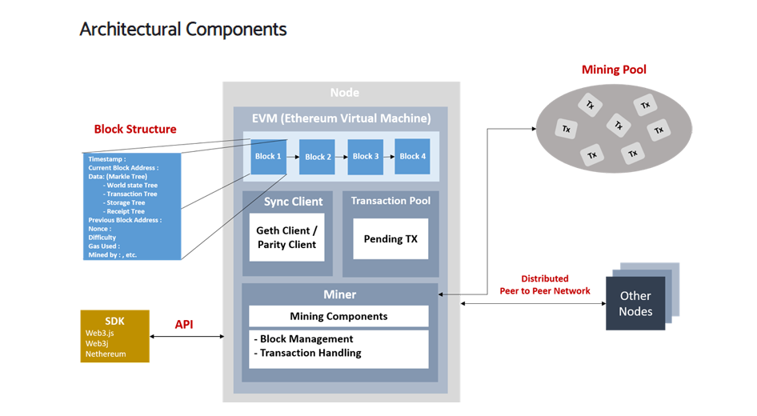

Source : <https://www.flentas.com/ethereum-architectural-overview>

This is an Ethereum typical architecture. I have included the source for the image. What is happening here is that each participant has a node, that connects with other nodes and a miner who mines data to ensure that the transaction is legit for the node. A node is any user or client device that is communicating with the Ethereum network. Each node contains blocks. Block is a package of data that stores transactions, hash of previous block (to keep a chain link network) and additional data like who was it mined by, fee (gas used).. Miners are the ones who add a block to the network once the transaction is confirmed. Mining Pool are just groups of miners doing their mining, confirming transactions together. SDKs are just different libraries used to interact with nodes on the network.

***Hyperledger***

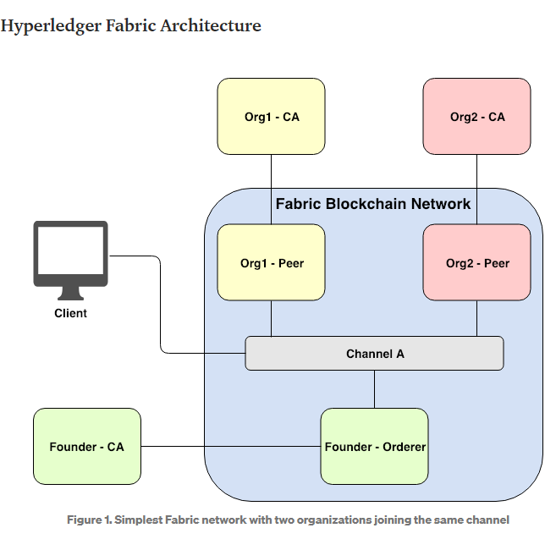

Source : <https://medium.com/coinmonks/demystifying-hyperledger-fabric-1-3-fabric-architecture-a2fdb587f6cb>

This is a simple Hyperledger typical architecture. A channel is like a link that helps all the organizations to communicate with each other. Since Hyperledger is a private network, this means anyone who is not in the channel can not access any data. Peer is the node that stores all the transactions when they join the channel – ensuring confidentiality. Orderer is responsible for ordering transactions and creating new block of ordered transactions. CA is the certificate Authority for managing registrations, user enrollments and stuff – user data. Client is considered to be an application that interacts with network based on the permissions It has been specified.

***Loyalty Program***

Thinking about the platforms and loyalty programs. There are a few things to be kept in mind. It would be good to have the program on Hyperledger Fabric for privacy purposes – any user might not want others to know how much loyalty points they have earned.